**Inca Road System Archeological Site**

**Identification Project**

Jeffrey Kennedy

Humboldt State University

December 2017

**ABSTRACT**

In order to better understand the Incan empire archeologists seeks out new archeologists sites. Inca road system (IRS) stretched for thousands of miles through the Andes Mountains and connects several known archeologists sites. Due to its importance and the remoteness of much of it's length, the IRS is a prime place to look for new, undiscovered and undisturbed archeological sites. Building upon previous research, values were assigned to distance from predicted IRS sites, distance from rivers, distance from roadways, and distance from the IRS itself, to create a cost analysis map of where new archeological sites might be located. With this map several spots of high probability were chosen at random for visual inspection which revealed three candidate archeological sites. Further variables, such a slope data may make future iterations of the map more accurate.

**TABLE OF CONTENTS**

**ABSTRACT**…………………………………………...………………………………………. 1-1

**TABLE OF CONTENTS**...…………………………...………………………………………. 2-2

**INTRODUCTION**…………………………………...………………...……………………… 3-6

*Literature Review*……………………………………………………………………… 3-5

*Goals*…………………………………………………....……………………………… 5-6

**METHODS**…………………………………………………….……….…...………………… 6-8

*Importing Data*…………...…………………………….……………………………… 6-7

*Creating Buffers*………………………………………..……………………………… 7-7

*Adding Costs*………………………………………...………………………………… 7-8

*Visual Check*…………………………………………………………………………… 8-8

**RESULTS**……………………………………………………………..………....…………… 8-14

*Location A*………………………………………..……….….……………………… 11-11

*Location B*…...…………………………………...…………….…………………… 12-12

*Location C*…………………………………………………...……………………… 13-14

**CONCLUSION**……………………………………………………...……………………… 14-15

**ACKNOWLEDGMENTS**…………………………………………...……………...……… 15-15

**REFERENCES**………………………………………………………...……………....…… 16-16

**LIST OF TABLES AND FIGURES**

**Table 1:** Costs Added to Buffers…………………………………………...………….........…… 8

**Figure 1:** Select Spots Along The IRS………………………………………..…….……....…… 9

**Table 2:** Random Sites and Results………………………………………………..............…… 10

**Figure 2:** Location A.……………………………...……………………………………....…… 11

**Figure 3:** Location B.………………………………………………………………...…...….… 12

**Figure 4:** Location C.………………………...………………………………………........…… 13

**Figure 5:** Location C in Greater Detail…………………………………………………….…… 13

**Table 3**: Sources of Data………………………………………………………..………….…… 15

**INTRODUCTION**

The Incan empire was cut short by the arrival of Spanish conquistadors in the late 1400s, the resulting conflict was enough to end the Incan empire and the loss of cultural knowledge and artifacts cannot be overstated. To fill in the many gaps modern scholars have in their understanding of the Incan empire, archeologists seeks out new archaeological sites, especially those that may be undisturbed. The likelihood that a site has remained undisturbed is increased by the remoteness, as the Inca road system (IRS) stretched for thousands of miles through the remote Andes Mountains, this may be an ideal place to look to find new, undisturbed archaeological sites.

As a road for travel the IRS, and with humans having a limit to how far they can travel in a day, it stands to reason there would be places not too far from the IRS which might have served essentially as rest stops. These rest stops may have been picked because, or became, cultural sites, over years of use. Because of this, its stands to reason that archeological sites might be spread out semi-equidistantly along the IRS based on the average distance of people would travel in a day.

**Literature Review**

GIS based approaches to modeling the potential archeological sites in the Andes Mountains in not without precedent. In “High-altitude ceremonial sites in the Peruvian Andes: GIS modeling. Carbon Climate and Society Initiative” the authors used their past experience with glacier melt revealing new archeological sites in Alaska and brought it to the Andes (Racoviteanu, 2002). The authors looked to use geo-visualization to better understand the religious or cultural stimuli for the selection of high-altitude archaeological site location within the Andes Mountains. The authors suggested that the sites were selected primarily based on water supply such as mountaintops, glaciers, and rivers. Using 30m DEM data and these restrictions as well proximity to mountain roads and cites the authors created a broad sweeping color gradient probability map for potential archeological site locations. However the authors were not able to verify any of the probabilities given the broadness in which they looked at their data.

As a testament to the use of the IRS as a means of travels and transportation of goods, a “How far to Conchucos? A GIS approach to assessing the implications of exotic materials at Chavín de Huántar” looked at the IRS and Chavín de Huántar in the Andes Mountains to assess distances and routes exotic materials found at the site must have traveled (Contreras, 2011.) The author used board digitizations of the IRS, DEM data, possible source points of the identified exotic materials, and Chavín de Huántar as the endpoint to create a least cost path model. Using this model the author made predictions of which route and location was the most likely source for the materials found at this archeological site.

On the opposite scale of some of the broad approaches the IRS itself has also been the subject of it's own very fine-toothed scale GIS investigation. “Innovative Technologies Used to Investigate Segments of the Inca Road. Journal of Professional Issues in Engineering Education and Practice” used a wide variety of methods, such as communication equipment, cameras, GIS modeling, GPS, and laser range finders to create very precise 3D models of particular road features (Jaselskis, 2013). Even to the point of using ground penetrating radar to investigate subsurface conditions. The authors hoped to use this data to gain a better understanding of site selection and design decisions which were made during the construction of this road system. One of the engineering discoveries the authors spoke of was the importance of working around and with sources of water, a factor also mentioned by Racoviteanu et al.

As far as specific site identification along the IRS “2.3 Beyond the Basemap: Multiscalar Survey through Aerial Photogrammetry in the Andes.” used case studies of select individual archeological sites along the IRS as examples of both the limitations and the possibilities in the Inka Royal Highway Digital Heritage Management Project (Wernke, 2013). This digitization project uses unmanned aerial vehicle (UAV) based photogrammetry to digitize sections of the IRS and scout for associated archaeological sites. The authors also use the UAV to create detailed maps and obtain high resolution DEM data which can aid heritage management and future site discovery locations, and increased cultural understanding as far as placement and site selection. The authors believe that this digitization to be especially important as cultural sites have been destroyed in the past.

“Networks, Territories, and the Cartography of Ancient States” takes a much larger scale approach to using cartography to help understand the Inca (Smith, 2005). The author used a nodes-and-corridors model approach to broadly look at the Inca, among other ancient polities. The author claimed that using a network model allows a better understanding of ancient states by looking at the overlapping geographic nodal points with their sometimes non-overlapping functions. The author was especially interested in ancient borders and the interaction and thus definition given by two competing polities. While this paper did not help much for figuring out or predicting where new archeological site might be, it had a great map which showed ancient, modern, and most importantly modern towns which overlay ancient Inca sites and how they relate to the IRS, which will later help in the selection of a road segment.

In addition to setting forward some of the limitations and hang-up to be avoided in conducting similar GIS modeling in the Andes, these papers have illustrated some available data sources and approaches for identifying archaeological sites or narrowing their locations down.

**Goals**

1. To perform a cost analysis on a section of the IRS which predicts the locations where additional archaeological sites may be found.
2. To test whether this method of identifying possible archaeological sites is a viable approach.
3. To identify any additional archaeological sites around the selected section of the IRS

**METHODS**

**Importing Data**

From this data I extracted a points shapefile with the locations all known associated archeological sites along the Qhapaq Nan stretch of the IRS and two separate sections of the IRS, which I combined into one. Using the measuring tool I got the distance between all known associated archeological sites and removed the outliers (distances over 10 miles and less than .25 miles, as I assumed they were the same site). This game me an average distance between sites as 1.71 miles. I also imported shapefiles of Peru hydrology and roadways. With the combined IRS I used the Editor Merge and then Construct Points tools to create points all along the IRS at an intervals of 1.71 miles. In total this created 589 points.

**Creating Buffers**

In order to assign a cost to different factors based on proximity buffers needed to be created around the various point and lines. First I created a 10 mile buffer around the IRS itself to use as a way to reduce the area that needed to be created in order to speed up processing. I used the intersect tool and the 10 mile buffer to leave only the sections of river and roadway data which were close to the IRS. For the rivers I created buffers at 660 feet (1/8 of a mile), 1320 feet (1/4 of a mile), 2640 feet (1/2 of a mile), and at 1 and 3 miles. For roads, a single buffer was created at 100 feet. For the IRS itself, several buffers were created at the same intervals as the rivers with the addition of one at 1760 feet (1/3 of a mile). For the 589 points spaced along the IRS at intervals of 1.71 buffers were created around them at 1/4, 1/3, and 1/2 miles.

**Adding Costs**

A new Cost field was added to each of the buffers and populated with appropriate values using the Field Calculator. The 100 foot buffer around the modern roadways was given a value of 10, with the assumption that sites directly along the would have been destroyed in construction or already discovered. As the Incan selected sites primarily based on water supply so I assumed the buffers closer to a river received a lower cost value (Racoviteanu, 2002). Areas closer to the IRS received lower values, as currently known sites seemed to be clustered closer to the IRS rather than spread out away from it. Finally areas closer to the predicted 589 points based on the average distance between known archeological sites.

Using either the Point to Raster or Polygon to Raster tool buffers were turned into raster files and appropriately reclassified. Each related polygon was then combined using the Raster Calculator and reclassified again. Finally all cost layers, Roadways, Rivers, IRS Distance, and Predicted IRS Sites, were also combined with the Raster Calculator tool and reclassified. Color was applied to allow areas with the lowest costs, and therefore highest likelihood of being an archeological site, to stand out.

***Table 1****: Costs Added to Buffers*

|  |  |  |  |  |  |
| --- | --- | --- | --- | --- | --- |
| **ATTRIBUTE** | **BUFFER** | **COST** | **ATTRIBUTE** | **BUFFER** | **COST** |
| **IRS Distance** | 1/8 Mile | 1 | **Rivers** | 1/8 Mile | 1 |
|  | 1/4 Mile | 2 |  | 1/4 Mile | 2 |
|  | 1/3 Mile | 4 |  | 1/2 Mile | 3 |
|  | 1/2 Mile | 6 |  | 1 Mile | 5 |
|  | 1 Mile | 8 |  | 3 Miles | 7 |
|  | 3 Miles | 9 |  | >3 Miles | 10 |
|  | >3 Miles | 10 | **Rivers** | > 100 Feet | 1 |
| **Predicted IRS Sites** | 1/4 Mile | 2 |  | 100 Feet | 10 |
|  | 1/3 Mile | 3 |  |  |  |
|  | 1/2 Mile | 4 |  |  |  |
|  | >1.2 Miles | 10 |  |  |  |

**Visual Check**

Finally, a twelve random spots that stood out on the cost map were visually inspected using the Bing Satellite Imagery map available through ArcGIS. Areas of interest within those visually inspected where then double checked using the slightly more recent and better resolution Google Satellite Imagery Maps.

**RESULTS**

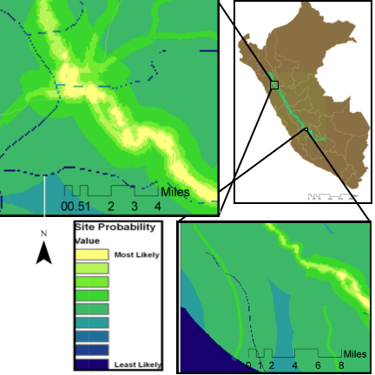

***Figure 1:*** *Select Spots Along The IRS (Locations B and C).*

A large scale map was created for the the entirety of the Qhapaq Ñan section of the IRS, which showed the probability of archeological sites as shown thrown raster cost analysis. A color was applied to make predicted sites glow.

Unfortunately the map system did have it’s limitations. It’s size, which great for visual searching in ArcGIS, it does not convert well to small maps. Also the project was slightly hampered by the limited number of variables used to apply costs to, the data was heavily skewed by the Predicted IRS Sites point data and buffers. This data was based loosely on archaeological data, but felt more arbitrary than I would have liked as updated finds will most likely change the average distance, potentially dramatically.

However, despite its limitations overall the map was successful, and allowed for all three stated goals to be met. 1. A cost analysis was prefered on the Qhapaq Nan section of the IRS. 2. This method provided results that gave relatively accurate predictions for possible sites, of the twelve random location that were chosen five had potential sites nearby, 42% success rate, although this number is based on a small sample, and misidentification of modern sites may account for more than one of the potential sites. 3. Ultimately, three sites were identified as the clearest and least likely to be a result of misidentification for a closer look. Those three are reviewed in this section.

***Table 2****: Random Sites and Results.*

|  |  |  |
| --- | --- | --- |
| **Site Number** | **Possible Site** | **Name** |
| **1** | Yes | Location A |
| **2** | Yes |  |
| **3** | No |  |
| **4** | Yes |  |
| **5** | No |  |
| **6** | Yes | Location B |
| **7** | No |  |
| **8** | No |  |
| **9** | No |  |
| **10** | No |  |
| **11** | No |  |
| **12** | Yes | Location C |

In the following images, a different color scheme was used to illuminate potential sites better on closer examination, with the redder the pixel the higher the likelihood of being an archeological site. Identified possible archeological sites are noted with an arrow.

**Location A**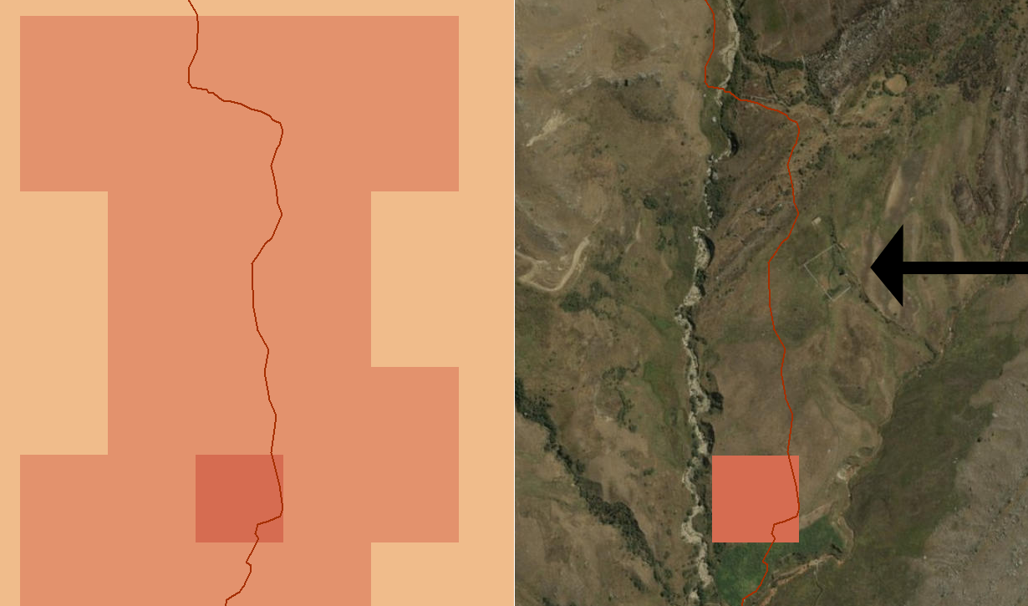

***Figure 2:*** *Location A.*

Location A appears to be the foundation of a building. Looking on Google Satellite Imagery shows a tag for "Huaygorral" at the location, which may be the name of the hill, or the site itself, although it was not included in the known archeological sites associated with IRS data that was provided. This site is located at -8.018719 -78.012247 Decimal Degrees with the predicted site roughly .20 miles away at -8.021279 -78.013104 Decimal Degrees.

**Location B**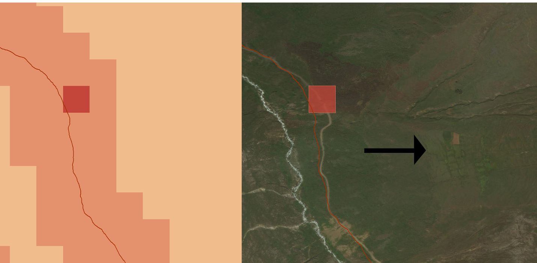

***Figure 3:*** *Location B.*

Location B appears to be abandoned agricultural terraces. This site is located at -8.219332, -77.922106 Decimal Degrees with the predicted site roughly .28 miles away at -8.221399 -77.918040 Decimal Degrees.

**Location C**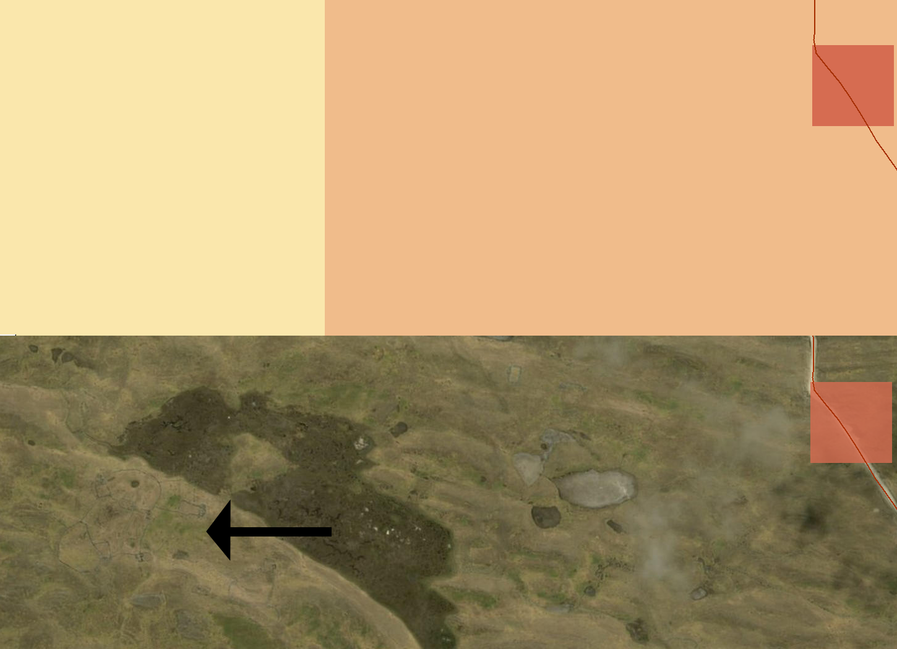

***Figure 4:*** *Location C.*

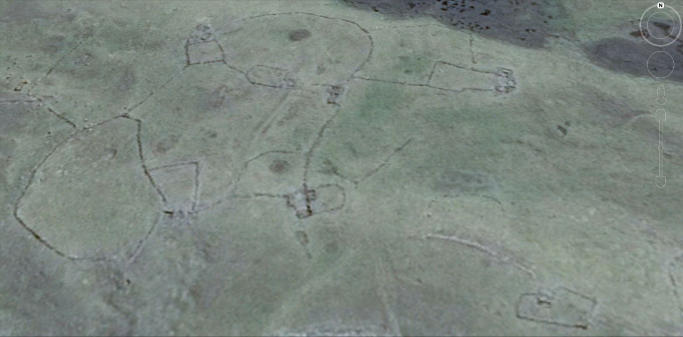

***Figure 5:*** *Location C in Greater Detail (Google Satellite Imagery).*

Location C is perhaps the most interesting of the potential sites, although I won't venture a guess at it's role. This site is located at -12.607284 -74.802175 Decimal Degrees with the predicted site roughly .61 miles away at -12.608068 -74.810985 Decimal Degrees. An additional close up of the site was taken for a closer inspection.

Each of these three sites, ended up being less than a mile off from rasters with the highest probabilities, and both locations A and B fell within rasters that had the second highest probability, with Location C only being one or two pixels outside that range as well. Overall I would say that although the map could use improvement, the initial test was more than successful.

**CONCLUSION**

While three sites were identified as potential archeological sites rather quickly there is a number of factors that could account for this rather than simply accuracy of the map. 1. There could be so many archeological sites it isn't uncommon to find them near any given spot. This possibility is especially relevant with Image 2. Terracing for agriculture spread out for miles and an archeological site may not even necessarily be nearby. In future iterations of this project it might be beneficial to define what an archaeological site is and is not. 2. Lack of training in site identification has lead to a mis-identifying of modern sites as archeological. Several other spots were identified which I felt more unsure than the three which ultimately were used, and thus passed up for inclusion in this report. Switching back and forth between Bing and Google Satellite Imagery Maps were helping and narrowing down this possibility. Of the included locations, Location C has the highest possibly of being a misidentified modern site, possibly being modern fencing for animals.

Overall I believe that this technique has the potential to reveal archaeological sites around the IRS. However I have came up with some improvements since the project end which might improve the results. 1. 30m DEM data, the one I originally tried to use was bad resolution and the resulting slope data was not included in the cost analysis. I predict slope would be an important factor in site location and would greatly improve the results. 2. City or population data would go a long way to narrowing down locations for the same reason the Roadway data helped, it might also reduce confusion between modern and archeological site. 3. Perhaps a .25 mile buffer around known archaeological sites to also help reduce the potential for re-identification of already discovered sites.

**ACKNOWLEDGMENTS**

***Table 2****: Sources of Data Used in the Inca Road Archeological Site Identification Project*

|  |  |
| --- | --- |
| **Data** | **Source** |
| IRS Digitization 1 | [qhapaq-nan.org](http://qhapaq-nan.org) |
| IRS Digitization 2 | [qhapaq-nan.org](http://qhapaq-nan.org) |
| Archaeological Site Digitization | [qhapaq-nan.org](http://qhapaq-nan.org) |
| Roadways Digitizations | [DIVA-GIS](http://www.diva-gis.org/) |
| Rivers Digitizations | [DIVA-GIS](http://www.diva-gis.org/) |
| Satellite Imagery | Bing Maps |
| Satellite Imagery | Google Maps |

**REFERENCES**

Contreras, D. A. (2011). How far to Conchucos? A GIS approach to assessing the implications of exotic materials at Chavín de Huántar. World Archaeology, 43(3), 380-397. doi:10.1080/00438243.2011.605841

Jaselskis, E. J., Schexnayder, C. J., Fiori, C., Becker, T. C., Hung, W., Beckman, C., . . . Alarcon, D. (2013). Innovative Technologies Used to Investigate Segments of the Inca Road. Journal of Professional Issues in Engineering Education and Practice, 139(3), 187-195. doi:10.1061/(asce)ei.1943-5541.0000145

Racoviteanu, A., Ackerman, T., Williams, M. and Manley, W. (2002). High-altitude ceremonial sites in the Peruvian Andes: GIS modeling. Carbon Climate and Society Initiative (NSF/IGERT) and Long-Term Ecological Research (LTER). Colorado.

Smith, M. L. (2005). Networks, Territories, and the Cartography of Ancient States. Annals of the Association of American Geographers, 95: 832–849. doi:10.1111/j.1467-8306.2005.00489.x

Wernke, Steven A, et al. (2016) “2.3 Beyond the Basemap: Multiscalar Survey through Aerial Photogrammetry in the Andes.” Mobilizing the Past for a Digital Future: the Potential of Digital Archaeology, The Digital Press @ the University of North Dakota, pp. 251–278.